**612/3**

**IPS ART & CRAFTS**

**Paper 3**

**Jul / Aug 2019**

**3 hours**

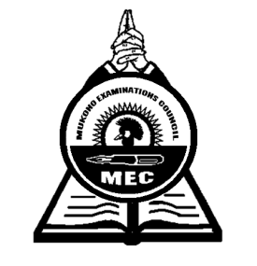

**MUKONO EXAMINATION COUNCIL**

**Uganda Certificate of Education**

IPS ART AND CRAFTS

DRAWING/PAINTING FROM HUMAN FIGURE

Paper 3

**3hours**

**Alternative subjects**

**EITHER** (Full figure)

1. Candidates draw or paint a whole figure of a male with a straw hat standing holding a long walking stick (about 2 m high) with the right hand, close to his body. The stick touches the ground as his support.

The model wears a long sleeved robe (kanzu) tied with a string torn from another piece of cloth around his waist with a noose to make a knot.

The right foot should be thirty centimeters ahead of the left foot. The model faces the candidate directly and appears to be in a thoughtful mood.

**OR**  (Portrait)

1. A girl/ boy (about 18 years old), sits on a locker at a three quarter angle, and slightly bends down.

The model is dressed in pair of trousers and short sleeved T-Shirt. The model’s hair is uncombed and hides both his / her hands at the back.

Candidates draw or paint the upper part of the model from the waist.

***End -***